**Psychology &Sociology**

**Personnel &Index**

**Sciences &**

**Health**

**Professions**

**Course**

**Descriptions**

**Graduate**

**School**

**Education**

**Albany State**

**Business**

**Arts & Humanities**

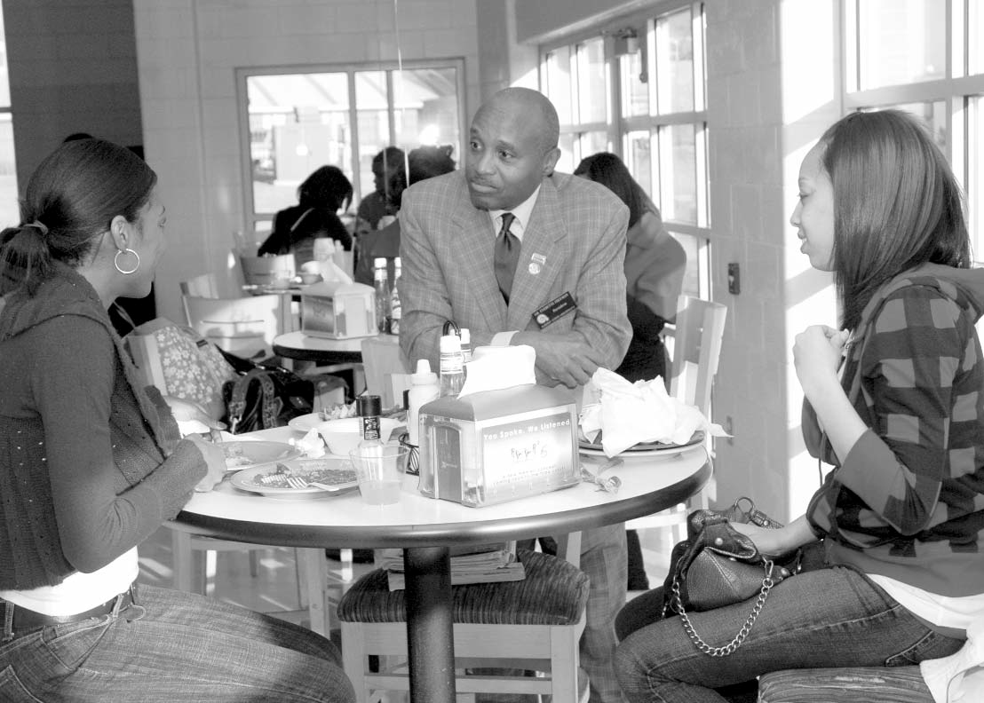

**Arts & Humanities**

DEPARTMENT OF Behavioral SciencesThe Department of Behavioral Sciences ( and offers degrees in psychology and sociology .

**PSYCHOLOGY**

The major in Psychology provides courses that lead to a Bachelor of Arts degree in psychology. The student who majors in psychology gains a fundamental understanding of the principles of human thought, emotion and behavior programs. In addition to the program’s emphasis on psychological factors and human learning, biological and social determinants of human behavior are also emphasized as well as research methods. This broad based training prepares students to understand, evaluate and influence their own behavior as well as the behavior of oth- ers. Because psychology is relevant to numerous fields, job opportunities for psychology majors are diverse and include employment in such areas as business and industry, educational settings, mental health agencies and hospitals, governmental agencies (including the military and law enforcement), etc. Students who plan to become professional psychologists or mental health practitioners will be prepared to continue their education in order to obtain a graduate degree in one of the more than 50 areas of specialization within psychology. The Psychology program is a member of the Council of Undergraduate Programs in Psychology. Departments with undergraduate programs in psychology, in institu- tions accredited for such purposes by their regional accrediting association, are eligible for membership on the council.

The major in Psychology requires:

1. Completion of a minimum of 120 semester hours with a cumulative grade-point average of at least 2.0.

2. Completion of all major courses with grades of “C” or above.

3. Completion of all required examinations: Psychology test of the Graduate Records Examination (GRE), or the Major Field Area Test and a departmental exit examination.

2008-2012 Undergraduate Catalog

**Psychology & Sociology**

**Sciences &**

**Health**

**Professions**

**Graduate**

**School**

**Course**

**Descriptions**

**Personnel &Index**

**Albany State**

**Education**

**Business**

**Arts & Humanities**

**Arts & Humanities**

**SOCIOLOGY**

The major in Sociology provides courses that lead to a Bachelor of Arts degree in sociology. The sociology program offers a variety of courses designed to enhance the knowledge of socio-cultural environments, human social behavior and social groups. In contrast to psychology, which focuses on individual behavior, sociology examines human behavior at the group level. Sociologists attempt to explain how and why society changes over time, and how and why societies differ from one another. The program of study in sociology provides students with adequate competencies for successful graduate study in sociology, other related behavior sciences, gerontology and religion. The degree provides some employment options at the bachelor’s level and by carefully selecting sociology and allied electives, students can enhance their employment possibilities. Sociology majors can also pursue a dual degree with either psychology or social work as the second major.

The major in Sociology requires:

1. Completion of 120 semester hours with a cumulative grade-point average of at least 2.0.

2. Completion of all major courses with grades of ”C” or above.

3. Completion of all required examinations: Sociology Test of the Graduate Records Examination (GRE), or the Major Field Area Test and a departmental examination.

**MINORS IN PSYCHOLOGY AND SOCIOLOGY**

The Department of Behavioral Sciences also offers minors in psychology and sociology. A minor program requires eighteen (18) semester hours in upper level prescribed courses along with elective courses. The department offers minors in psychology and sociology to enhance employment opportunities and/or preparation for graduate school. Each of the minors requires eighteen (18) semester hours of lower and upper level courses.

**MINOR IN PSYCHOLOGY**

Psychology 18 hours

**MINOR IN SOCIOLOGY** Anthropology 18 hours Gerontology 18 hours Sociology 18 hours Urban Studies 18 hours

2008-2012 Undergraduate Catalog

**Psychology**

**Personnel &Index**

**Sciences &**

**Health**

**Professions**

**Course**

**Descriptions**

**Graduate**

**School**

**Education**

**Albany State**

**Business**

**Arts & Humanities**

**BACHELOR OF ARTS DEGREE IN PSYCHOLOGY**

**Area F - Courses Related to Major (18 hrs) Credit Hrs.**

1000-2000 level Grade “C” or better

|  |  |  |  |
| --- | --- | --- | --- |
| PSYC | 1101 | General Psychology | 3 |
| PSYC | 2203 | Professions of Psychology | 3 |
| PSYC | 2295 | Psychology of Adjustment | 3 |
| PSYC | 2270 | Psychology of Ethics | 3 |

**Area F Choice (Select 6 hours)** Grade of “C” or Better

|  |  |  |  |
| --- | --- | --- | --- |
| SOCI | 2601 | Urban Social Problems | 3 |
| ECON | 2201 | Survey of Economics | 3 |
| SSCI | 2402 | Microcomputers in the Social Sciences | 3 |
| MDLG |  | Foreign Language (Option) | 3 |
| PSYC | 1001 | Study Management | 3 |
| PSYC | 4400 | Applied Health Psychology | 3 |

(Required Major Courses 15 Hours) Grade of “C” or better

PSYC 4300 Behavioral Statistics 3

PSYC 4304 Behavioral Research 3

PSYC 4305 Experimental Psychology 3

PSYC 4465 History and Systems (req.) 3

PSYC 4499 Psychological Seminar 3

**Major Electives (3000-4000 level) 27 Hours**

Supportive Courses

Any advisor-approved courses in the area of sociology, criminal justice, economics,

political science, social work, allied health sciences and education. A grade of “C” or better is required. 6

General Electives 8

**Total Hours Required 123**

2008-2012 Undergraduate Catalog

**Psychology**

**Sciences &**

**Health**

**Professions**

**Graduate**

**School**

**Course**

**Descriptions**

**Personnel &Index**

**Albany State**

**Education**

**Business**

**Arts & Humanities**

**Arts & Humanities**

**PROGRAM OF STUDY FOR THE BACHELOR OF ARTS DEGREE IN PSYCHOLOGY**

123 Semester Hours

|  |  |  |  |
| --- | --- | --- | --- |
| **Freshman Year**  ENGL 1101 | Composition I | **Fall**  3 | **Spring** |
| ENGL 1102 | Composition II |  | 3 |
| PSYC 1101 | General Psychology | 3 |  |
| MATH 1111 | College Algebra or |  |  |
| MATH 1101 | Math Modeling | 3 |  |
| COMM 1100 | Fundamental of Public Speaking |  |  |
| ASU 1200 | Freshman Seminar & Service to Leadership | 3 |  |
| HIST 1002 | Intro. to the African Diaspora | 3 | 2 |
| PEDH (1001 - 1007) | (any courses available) |  | 2 |
| Area D Option |  |  | 3 |
| MUSC 1100 | Music Appreciation |  | 3 |
| SOCI 2031 | Intro. to Anthropology |  | 3 |
| HEDP 1001 | Intro. to Wellness | 1 |  |
| **Total** |  | **16** | **16** |
| **Sophomore Year** |  |  |  |
| ENGL 2111 | World Literature I | 3 |  |
| PHYS 1111K | Intro. to Biology |  |  |
| or PHYS 1001K | Physical Science | 4 |  |
| SSCI 2402 | Microcomputers In the Social Sciences | 3 |  |
| PSYC 2295 | Psychology of Adjustment | 3 |  |
| Area D Science |  |  | 3-4 |
| ECON 2105 | Principles of Macro Econ. | 3 |  |
| HIST 1111 | Survey of World History I (required) |  | 3 |
| SOCI 2011 | Principles of Sociology (Required) |  | 3 |
| POLS 2101 | Intro. to Political Science 3 |  |  |
| PSYC 2203  **Total** | The Profession of Psychology | **16** | 3  **15-16** |
| **Junior Year** |  |  |  |
| PSYC 2290 | Foundations of Learning and Motivation | 3 |  |
| PSYC 2270 | Psychology of Ethics | 3 |  |
| SOCI 2601 | Urban Social Problems | 3 |  |
| PSYC Elective |  | 3 |  |
| MDLG | Foreign Language (Option) | 3 |  |
| PSYC 2275 | Interviewing Strategies |  | 3 |
| PSYC 4300 | Behavioral Statistics |  | 3 |
| PSYC Electives |  |  | 9 |
| **Total** |  | **15** | **15** |
| **Senior Year** |  |  |  |
| PSYC 4304 | Behavioral Research | 3 |  |
| PSYC 4305 | Experimental Psyc. |  | 3 |
| PSYC 4499 | Psychological Seminar | 3 |  |
| PSYC 4470 | Practicum in Psychology | 3 |  |
| Psychology Electives |  | 6 |  |
| PSYC 4465 | History and Systems (Req.) |  | 3 |
| PSYC Electives |  |  | 9 |
| **Total** |  | **15** | **15** |

2008-2012 Undergraduate Catalog

**Sociology**

**Personnel &Index**

**Sciences &**

**Health**

**Professions**

**Course**

**Descriptions**

**Graduate**

**School**

**Education**

**Albany State**

**Business**

**Arts & Humanities**

**Arts & Humanities**

**BACHELOR OF ARTS DEGREE IN SOCIOLOGY**

**Freshman Year Fall Spring** Area F Courses Related to the Major 18 hours Grade of “C” or better 1000-2000 level

|  |  |  |  |
| --- | --- | --- | --- |
| SOCI | 2011 | Principles of Sociology | 3 |
| SOCI | 2601 | Urban Social Problems | 3 |
| SOCI | 2031 | Introduction to Anthropology | 3 |
| PSYC | 2203 | The Profession of Psychology | 3 |

Area F - Choices (Select 6 hours) Grade of “C” or better

SSCI 2402 Microcomputers in the Social Sciences 3

ECON 2201 Survey of Economics 3

POLS 2102 Introduction to Law 3

POLS 2101 Introduction to Political Science 3

MDLG Foreign Language (Choice of Language) 3

(Required Major Courses 15 hours) Grade of “C” or better

SOCI 4300 Behavioral Statistics 3

SOCI 4304 Behavioral Research 3

SOCI 4451 Social Theory 3

SOCI 4454 Sociology Seminar 3

SOCI 3321 Population Problems 3

Major Electives (3000-4000 Level)

**Total 27**

Supportive Courses

Any advisor-approved courses in the area of sociology, criminal justice, economics, political science, social work,

allied health sciences and education. A grade of “C” or better is required. 6

General Electives 8

Total Hours Required 123

**PROGRAM OF STUDY FOR THE BACHELOR OF ARTS DEGREE IN SOCIOLOGY**

123 Semester Hours (Minimum)

**Freshman Year Fall Spring**

|  |  |  |  |  |
| --- | --- | --- | --- | --- |
| ENGL | 1101 | English Composition I | 3 |  |
| COMM | 1101 | Fundamental of Public Speaking | 3 |
| ASU | 1200 | Freshman Seminar & Service to Leadership | 3 |
| HIST | 1002 | Intro. to the African Diaspora |  | 2 |
| BIOL | 1111K | Intro to Biological Sciences* | 4 |  |
| HIST | 1111 | Survey of World History I | 3 |  |
| ENGL | 1102 | English Composition II |  | 3 |
| MATH | 1111 | College Algebra or |  |  |
| MATH | 1101 | Math Modeling |  | 3 |
| CSCI | 1101 | Intro. to Computers |  | 3 |
| HIST | 1112 | Survey of World History II |  | 3 |
| PSYC | 1101 | General Psychology |  | 3 |
| **Total** |  |  | **16** | **17** |

**Sophomore Year**

|  |  |  |  |  |
| --- | --- | --- | --- | --- |
| SOCI | 2011 | Principles of Sociology (Required) | 3 |  |
| ENGL | 2111 | World Literature I | 3 |
| PSYC | 2203 | Professions of Psychology | 3 |
| SSCI | 2402 | MicroComputers in the Social Science | 3 |
| PEDH (1001 - 1007) (any course available) 3 | | | |
| SOCI | 260 | Social Problems |  | 3 |
| SOCI | 2031 | Introduction to Anthro. |  | 3 |
| ECON | 2201 | Survey of Economics |  | 3 |
| POLS | 2101 | Introduction to Pol. Sci. |  | 3 |
| BIOL  **Total** | 1112K | Intro. to Biological Sciences II/Area D-Science | **15** | 3-4  **15-16** |

2008-2012 Undergraduate Catalog

**Sociology**

**Sciences &**

**Health**

**Professions**

**Graduate**

**School**

**Course**

**Descriptions**

**Personnel &Index**

**Albany State**

**Education**

**Business**

**Arts & Humanities**

**Arts & Humanities**

|  |  |  |  |  |
| --- | --- | --- | --- | --- |
| **Junior Year** |  | | | |
| SOCI | 4300 | Behavioral Stats. | 3 |  |
| SOCI | 3317 | The Culture of Africa | 3 |  |
| SOCI | 3329 | Community Mental Health | 3 |  |
| Electives |  |  | 6 |  |
| SOCI | 4304 | Behavioral Research |  | 3 |
| SOCI | 3321 | Population |  | 3 |
| SOCI | 3311 | The Family |  | 3 |
| SOCI | 3380 | The Black Church |  | 3 |
| Electives |  |  |  | 3 |
| **Total** |  |  | **15** | **15** |
| **Senior Year** |  |  |  |  |
| SOCI | 4451 | Social Theory | 3 |  |
| SOCI | 4454 | Sociology Seminar | 3 |  |
| SOCI | 3371 | Juvenile Delinquency | 3 |  |
| SOCI | 4454 | Sociology Seminar | 3 |  |
| Electives |  |  | 3 |  |
| SOCI | 3360 | Urban Sociology |  | 3 |
| PSYC | 4464 | Social Psychology |  | 3 |
| Electives |  |  |  | 9 |
| **Total** |  |  | **15** | **15** |



2008-2012 Undergraduate Catalog















2008-2012 Undergraduate Catalog

**Sciences &**

**Health**

**Professions**

**Graduate**

**School**

**Course**

**Descriptions**

**Personnel &Index**

**Albany State**

**Education**

**Business**

**Arts & Humanities**

**Arts & Humanities**

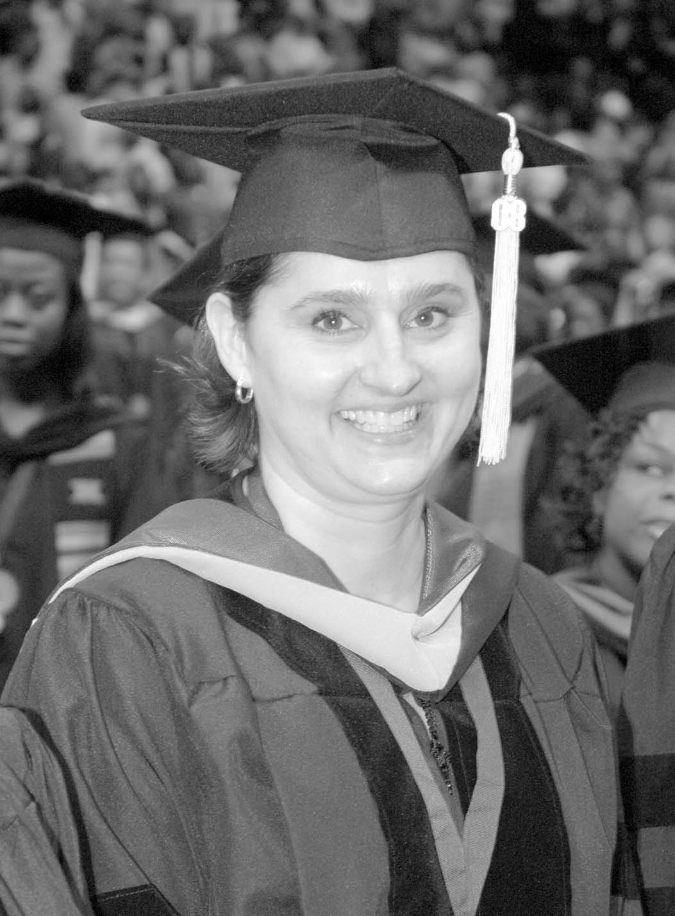

2008-2012 Undergraduate Catalog

**Personnel &Index**

**Sciences &**

**Health**

**Professions**

**Course**

**Descriptions**

**Graduate**

**School**

**Education**

**Albany State**

**Business**

**Arts & Humanities**

**Sciences &**

**Health**

**Professions**

**Graduate**

**School**

**Course**

**Descriptions**

**Personnel &Index**

**Albany State**

**Education**

**Business**

**Arts & Humanities**